EDUCATION GRANT  APPLICATION FORM  For young people in secondary school (S1-S6), further or higher education aged 25 and under | 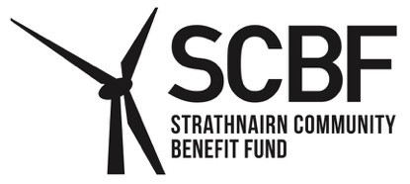

A single grant of £325 per academic year (August 2026 to July 2027) is available to support education costs, not funded by statutory provision, who are permanent residents of the Strathnairn Community Council area of either:

Children and young people aged 21 and under in secondary school (S1-S6), further or higher education.

Those undertaking a bachelor’s degree (or equivalent) up to the upper age limit of 25 is allowed. However, this is restricted to a single bachelor’s degree and not transferred between degrees. Applications to cover a second Bachelor’s degree will not be accepted.

If you received an Education Grant in 2025/26, you must submit a monitoring form showing how the award was spent before applying for a 2026/27 grant. The monitoring form was sent with your grant award letter. Copies are available from the SCBF website, or by emailing cosec@strathnairncbf.com.

If you are awarded a grant for 2026/27, awards for future academic years will be dependent on the submission of a monitoring form.

Your Details

Name of young person:
Age on last birthday:
School/college/University attended:
Parent/Guardian name (if under 16):
For children under 16, please provide the contact details of a parent or guardian. Young people aged 16 and over should give their own contact details.
Address:

Telephone number:
Email address:
Declaration:
- I declare that the information included in this application is correct.
- I understand that I may be contacted by SCBF to provide additional information or evidence relating to the grant.
- I understand that the Education Grant is to be spent on costs related to education.
- I understand that the decision made by SCBF is final.
- I confirm that the above address is my permanent residential address.
Signature:
Date:
Signature of parent/guardian for applications made relating to a child under 16. Signature of the young person for awards made relating to those 16 and over.
School/College/University Declaration Stamp

I confirm that

is a student at

Signature:

Position:

Date:

Please ask your school, college or university to complete the declaration above, and attach a copy of a utility bill, council tax bill or bank statement to confirm your address. You are free to obscure detailed account information, as long as your name, address and the sender are clearly visible.

By submitting this application you agree to allow SCBF to retain your personal data in order to process your application. It will use the information you give it to help assess your application and administer any grant it awards you. More information about how SCBF processes your data is available in its Privacy Notice which can be viewed online at www.strathnairncbf.com.

Deadline for receipt of applications is 30/06/27

Send completed form to the Secretary by email or post (no stamp required) to:
cosec@strathnairncbf.com or
Freepost RTTJ-HBSK-RRUU, SCBF, PO Box 5783, Inverness, IV1 9EW
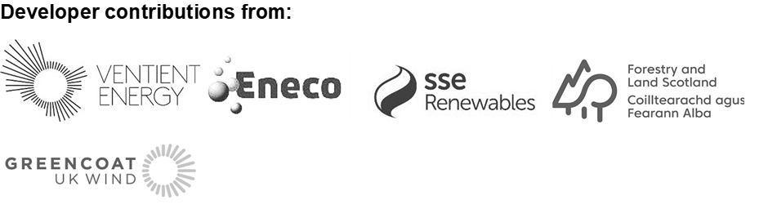

Payment Options

Payment of grants can be made by cheque or bank transfer. Please indicate your preference below:

Please pay by cheque / bank transfer (delete as applicable).

Payment will can be made to either the parent/guardian or young person (if aged 16 and over).

Payment by cheque:

Name

Payment by Bank Transfer:

Bank Account Details

Name

Bank Name

Bank Sort Code

Account Number

This record of your bank details will be destroyed once payment has been confirmed.

