EDUCATION GRANT  MONITORING FORM  Academic year 2026/27 | 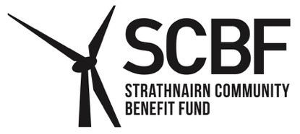

Strathnairn Community Benefit Fund launched its Education Grant in the 2019/20 academic year. The Fund is evaluating the Grant each year in order to assess the benefits it brings to young people in Strathnairn.

The grant is to be spent on non-statutory educational and extracurricular activities. This could include educational trips, sports activities, books and equipment, travel costs or other costs relating to educational activity.

Please complete this form to tell us about how you used the Grant. If the Education Grant is continued in 2027/28, applications will be dependent on submitting this completed form for 2026/27.

Please tell us about how you spent the Education Grant received from Strathnairn Community Benefit Fund:

Description | Cost £
Total

Tell us about how you/your child benefited from the Grant:

Your Details

Name of pupil/student/apprentice:
For awards made relating to a child under 16:
Name of Parent/Guardian:
Address:

Telephone Number:
Email Address:
Signature:
(Signature of parent/guardian for awards made relating to a child under 16. Signature of the student/apprentice for awards made relating to those 16 and over).
Date:
Data supplied on this form will not be shared with third parties and will be held in accordance with SCBF’s Privacy Notice which can be viewed online at www.strathnairncbf.com.

Send completed form to the Secretary by email or post (no stamp required) to:
cosec@strathnairncbf.com

Freepost RTTJ-HBSK-RRUU, SCBF, PO Box 5783, Inverness, IV1 9EW


