RENEWABLE ENERGY TECHNOLOGY GRANT  APPLICATION FORM | 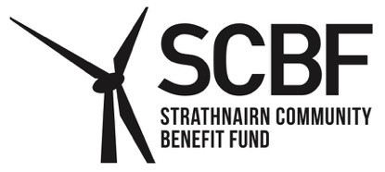

A grant of 20% up to a maximum of £1,250 may be available towards the initial installation of recognised renewable energy technology. The grant will not cover the replacement of current technology, nor the purchase of any plug-in solar panels. This includes solar PV/thermal, wind, biomass and air/ground source heat pumps. Any battery storage costs are to be part of the application, as it is not covered as a stand alone application (for example a solar application can include the battery storage cost, but a separate application for battery storage is not accepted).

The grant is only available to existing properties, over ten years old, used as a primary residence, within the Strathnairn Community Council area. The grant is not available for second homes, rental properties or holiday lets.

Grants must be received within 12 months upon completion of the work.

You can make a further application once every 10 years (as an example if a resident made an application in 2017 they would be eligible again in 2027 to apply for another grant). The grant will cover initial installation but will not cover maintenance or repair.

Contact details:
Name:
Address:

Telephone Number:
Email address:
Type of Renewable Technology: ______________________________________

Cost of Work: £___________________

Amount being claimed: £___________________

Please attach a copy of the quote or invoice. Please note that if your grant application is successful you will be required to provide a receipt once the work has been completed.

By submitting this application, you agree to allow Strathnairn Community Benefit Fund (SCBF) to retain your personal data in order to process your application. SCBF will use the information you give it to help assess your application and administer any grant it awards you. It may also use it to analyse its grant making for its own research or pass it to other organisations contracted to do specific work for SCBF. SCBF may give copies of this information to individuals and organisations it consults with when assessing applications, when monitoring grants and evaluating its grant-making. More information about how SCBF processes your data is available in its Privacy Notice which can be viewed online at www.strathnairncbf.com.

Declaration:
- I declare that the information included in this application is correct and if I do not provide the correct details my application may be rejected.
- I understand that I may be contacted by SCBF to provide additional information or evidence relating to the work.
- I understand that the decision made by SCBF is final.
- I confirm that I am the owner of the above property and that it is my permanent address.

Date_____________ Signature of Applicant___________________________

Deadline for receipt of applications is 31/08/2027

Send completed form to the Secretary by email or post (no stamp required) to:
cosec@strathnairncbf.com

Freepost RTTJ-HBSK-RRUU, SCBF, PO Box 5783, Inverness, IV1 9EW

