RELIEF OF HARDSHIP  GRANT  APPLICATION FORM | 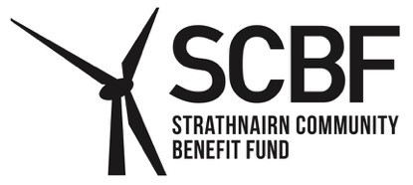

In exceptional circumstances a grant may be made available to individuals or households suffering severe financial hardship.

It is expected that the applicant to have investigated and applied for benefits and other statutory assistance you may be entitled to before approaching SCBF. For help and advice on entitlements, please contact Highland Council's Welfare Support Team on 0800 090 1004.

Funding is not available towards medical equipment or medical procedures where there is a reasonable expectation that these can be provided by the NHS. Treatments / procedures not supported by NHS cannot be considered.

Contact details:

Name:
Address:

Telephone Number:
Email address:
Number of residents in the household: Adults: _______ Children under 16: _________

Total gross household income in the last 12 months: £ ______

If your household is in receipt of means tested benefits, such as Universal Credit or Pension Credit, please list these below:

Please provide details of your current circumstances and the monies that you are applying for. If your application relates to the costs of special equipment, please supply evidence of these costs. Please note that all information will be treated as confidential:

By submitting this application, you agree to allow Strathnairn Community Benefit Fund (SCBF) to retain your personal data in order to process your application. SCBF will use the information you give it to help assess your application and administer any grant it awards you. It may also use it to analyse its grant making for its own research or pass it to other organisations contracted to do specific work for SCBF. SCBF may give copies of this information to individuals and organisations it consults with when assessing applications, when monitoring grants and evaluating its grant-making. More information about how SCBF processes your data is available in its Privacy Notice which can be viewed online at www.strathnairncbf.com.

Declaration:
- I declare that the information included in this application is correct and if I do not provide the correct details my application may be rejected.
- I understand that I may be contacted by SCBF to provide additional information or evidence of income and bills.
- I understand that the decision made by SCBF is final.

Date: _____________ Signature of Applicant: ______________________

If you have completed this form on behalf of somebody else, please contact SCBF, as we will need proof that you are able to act on their behalf.

Send completed form to the Secretary by email to: cosec@strathnairncbf.com

You may also send the application by post. However, an emailed application will provide a quicker response.

Freepost RTTJ-HBSK-RRUU, SCBF, PO Box 5783, Inverness, IV1 9EW



